Audit Template
Audit Title:
Thames Valley Audit on the Laboratory Investigation of Hypercalcaemia

Lead Auditor:  Emma Ashley | Audit date(s):  21st January 2014
Please indicate if Local / Regional / National Audit  Please indicate which hospital & location or region  Regional: Thames Audit Group | Report Author:  Name: Emma Ashley  Email: emmaashley@nhs.net
Aims of the Audit:
- Identify different practices across the region for the investigation and reporting of hypercalcaemia
- Provide local recommendations for the investigation of hypercalcaemia
- Establish an appropriate algorithm to assist the laboratory

Audit Method and Outcome(s):

An audit questionnaire was devised by the lead auditor and ratified by the Thames Audit Group (TAG) committee. It was then circulated to all members of the TAG and the responses analysed by the lead auditor. The findings were presented by the lead auditor at the meeting of the TAG on 21st January 2014.

Recommendations were drafted by the lead auditor, discussed and amended by the TAG committee and then further discussed and amended at the TAG meeting. The recommendations were ratified by the TAG committee at the meeting on 3rd June 2014.

Audit Recommendations / Standards:

- Laboratories should aim to use the Pathology Harmony reference ranges for adjusted calcium of 2.20 – 2.60 mmol/L wherever possible.
- It may not be advisable to measure PTH in a normocalcaemic patient (without CKD) to avoid confusion of how to act on a normocalcaemic result with a raised PTH. This combination of results is most commonly associated with secondary hyperparathyroidism due to vitamin D deficiency.
- A multi-disciplinary approach to the investigation and treatment of primary hyperparathyroidism (PHPT) is important. The aim of the laboratory is to provide the clinicians with the status of calcium, PTH and vitamin D in the patient before referral to Endocrinology. This should prevent unnecessary referral of patients who are not likely to have PHPT.
- PHPT should be biochemically confirmed including exclusion of familial hypocalciuric hypercalcaemia using calcium:creatinine clearance measurement, and other causes should be removed (eg. thiazide diuretics) or treated (eg. vitamin D deficiency) prior to radiological imaging.
- The following algorithm is suggested to be used on patients who present with hypercalcaemia in the first instance to their GP or for out-patients. The following comments may be used accordingly:
  - PTH consistent with a non-parathyroid cause of hypercalcaemia and the following causes should be considered: malignancy, vitamin D associated causes (eg. sarcoidosis) and FHH.
  - PTH is consistent with primary hyperparathyroidism, suggest endocrine referral.
  - Suggest replace vitamin D and repeat calcium, vitamin D and PTH in 6 months.
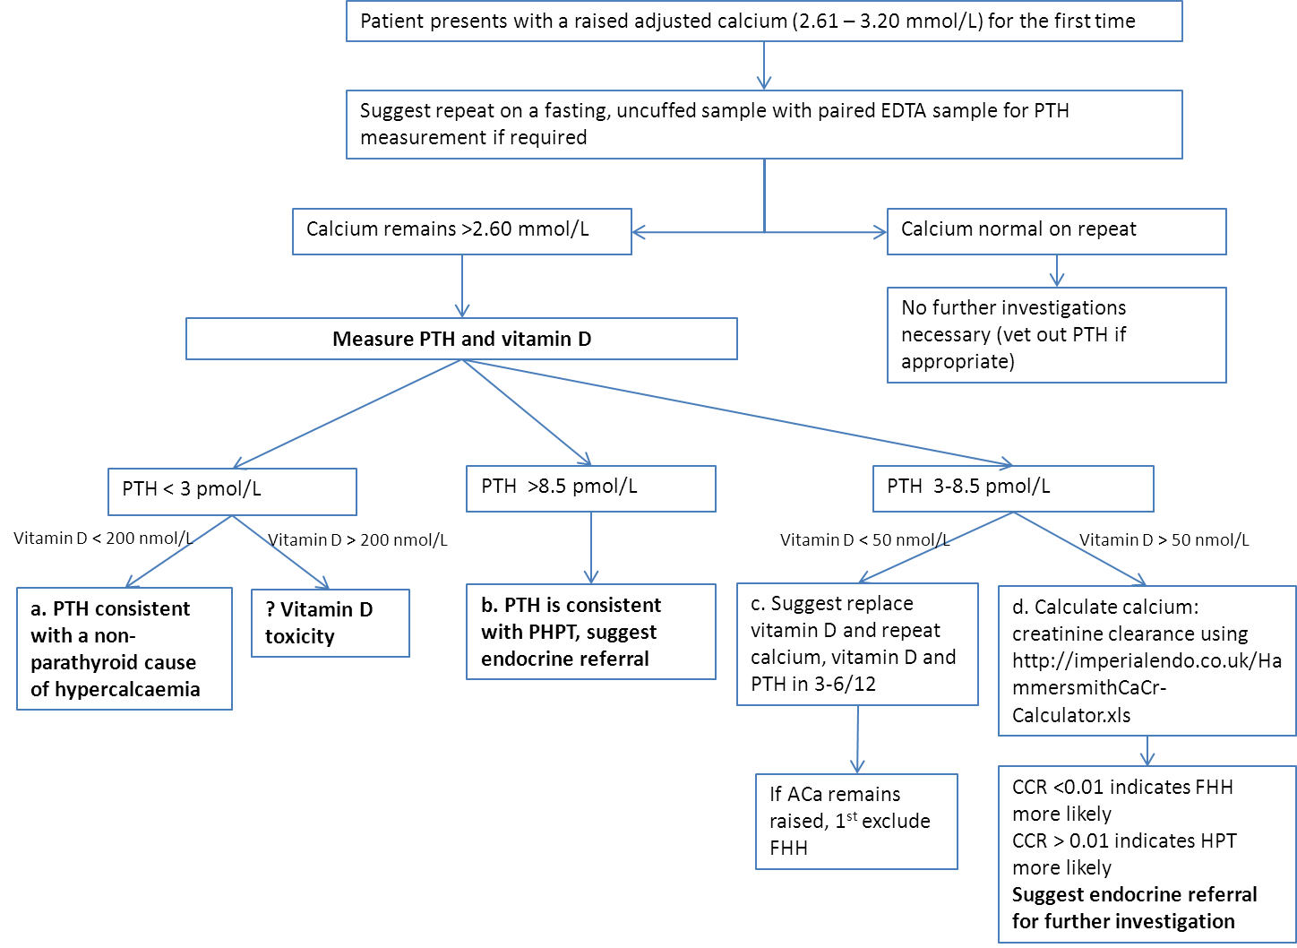
  - Suggest exclude FHH by sending repeat serum for UE and calcium plus urine sample for calcium/creatinine clearance. Otherwise results are consistent with primary hyperparathyroidism.

NB. PTH range used for the algorithm was obtained from: Clinical and laboratory features of calcium-sensing receptor disorders: a systematic review, Ian R Gunn and Dairena Gaffney. Ann Clin Biochem 2004; 41: 441–458
Please indicate to whom and when audit presented &/or circulated&/or published:
Audit findings presented at the meeting of the Thames Audit Group on 21st January 2014.

Audit recommendations / standards ratified by … and when:
Recommendations ratified by the Thames Audit Group committee on 3rd June 2014.

Date of audit report:
21st January 2014

Audit documents for upload to http://www.acb.org.uk/whatwedo/science/audit.aspx
Please include as attachments with this Audit Summary form if authors and the organising committee would like information to be publicly accessible on the ACB website Audit section.

