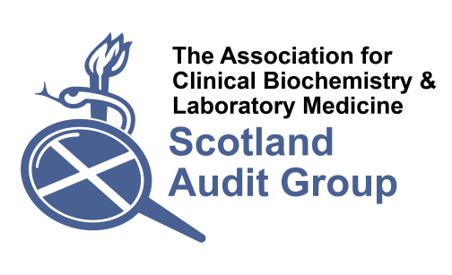
Audit of low volume endocrine testing in Scotland (2017)
On behalf of the ACB Scotland Audit Group

This Scotland-wide audit is intended to evaluate reporting procedures for low volume endocrine tests, for which standardisation may be poor. Where there is variation in the units and reference ranges used for the same analyte there exists potential risk to patients, and is an impediment to the harmonisation of patient care pathways. This audit will identify tests where efforts could be made to harmonise reporting.

Please fill in the table below by 30th June 2017 and email the completed questionnaire to catriona.clarke@nhslothian.scot.nhs.uk or post a completed paper copy to:

Catriona Clarke
Clinical Biochemistry and Haematology
Western General Hospital
Crewe Road South
Edinburgh
EH4 2XU

Which laboratories/hospitals are covered in this response:
Contact details of individual respondent:
If a test is not analysed locally then please fill in the external site and workload figures only.
Test name | analytical platform/  method | reporting units | reported reference range(s) | recent annual workload (please state dates) | External site of analysis if not performed locally | Any other relevant comments
androstenedione
DHEAS
17-OHP
dihydrotestosterone (DHT)
11-deoxycortisol
(11-DOC)
Test name | analytical platform/  method | reporting units | reported reference range(s) | recent annual workload (please state dates) | External site of analysis if not performed locally | Any other relevant comments
renin
aldosterone
insulin
C-peptide
AMH
ACTH
Test name | analytical platform/  method | reporting units | reported reference range(s) | recent annual workload (please state dates) | External site of analysis if not performed locally | Any other relevant comments
Growth Hormone (GH)
IGF-1
IGF-2
Calcitonin
Thyroglobulin
Thyroglobulin Abs
(or give details if other strategy of determining thyroglobulin assay interference is used)

Test name | analytical platform/  method | reporting units | reported reference range(s) | recent annual workload (please state dates) | External site of analysis if not performed locally | Any other relevant comments
TRABs
Plasma metadrenalines /catecholamines
(please specify what metabolites are included in the profile)
Urine metanephrine and/or catecholamines
(please specify what metabolites are included in the profile)

Urine 5-HIAA
Urinary cortisol
Prednisolone
Test name | analytical platform/  method | reporting units | reported reference range(s) | recent annual workload (please state dates) | External site of analysis if not performed locally | Any other relevant comments
Chromogranin A

Any other additional comments:

